1. **Develop a Java program that prints all real solutions to the quadratic equation ax2 +bx+c = 0. Read in a, b, c and use the quadratic formula. If the discriminate b2-4ac is negative, display a message stating that there are no real solutions.**

import java.io.*;

import java.util.*;

import java.lang.*;

public class quadratic

{

private static double a;

private static double b;

private static double c;

public static void read()

{

Scanner sc=new Scanner(System.in);

System.out.println("Enter the Co-Effcient a");

a=sc.nextDouble();

System.out.println("Enter the Co-Effcient b");

b=sc.nextDouble();

System.out.println("Enter the Co-Effcient c");

c=sc.nextDouble();

System.out.println("THANK YOU FOR ENTERRING THE CO-EFFCIENTS");

}

public static void calc()

{

read();

double d=b*b-4*a*c;

if(d>0)

{

System.out.println("ROOTS ARE REAL AND DISTINCT");

System.out.println("FIRST ROOT IS " + (-b+Math.sqrt(d))/(2*a));

System.out.println("FIRST ROOT IS " + (-b-Math.sqrt(d))/(2*a));

}

else if(d==0)

{

System.out.println("Roots are equal");

System.out.println("ROOTS ARE " + (-b)/(2*a));

}

else

{

System.out.println("ROOTS ARE IMAGINARY");

System.out.println("ROOTS ARE " + -b/(2*a) + "+" +"i" + (Math.sqrt(-d))/(2*a));

System.out.println("ROOTS ARE " + -b/(2*a) + "-" +"i" + (Math.sqrt(-d))/(2*a));

}

}

public static void main(String[] args)

{

calc();

}

}

output:

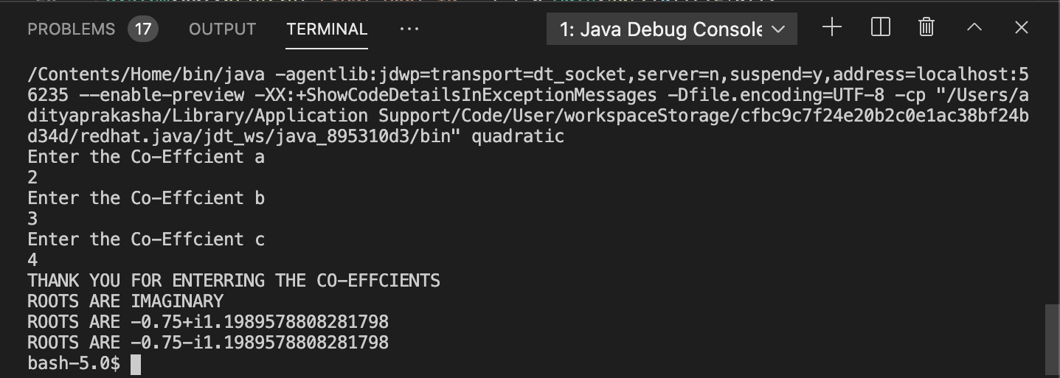

**2. Develop a Java program to create a class Student with members usn, name, an array**

**credits and an array marks. Include methods to accept and display details and a method to**

**calculate SGPA of a student.**

import java.util.Scanner;

class Student

{

private String USN;

private String name;

private int n;

private double SGPA = 0;

private int totalCredits = 0;

private int credits[];

private double marks[];

Scanner ss = new Scanner(System.in);

void Details()

{

System.out.println("Enter USN of the student");

USN = ss.nextLine();

System.out.println("Enter Name of the student");

name = ss.nextLine();

System.out.println("Enter no of subjects");

n = ss.nextInt();

credits = new int[n];

marks = new double[n];

System.out.println("*Enter details of the subjects:*");

for(int i=0;i<n;i++)

{

System.out.println("Enter credits allotted to the subject "+(i+1));

credits[i] = ss.nextInt();

System.out.println("Enter marks in the subject "+(i+1));

marks[i] = ss.nextInt();

Calculate(credits[i],marks[i],i);

}

}

void Calculate(int credit,double mark,int j)

{

totalCredits = totalCredits + credit;

if(mark>=90&&mark<=100)

SGPA = SGPA + (10*credit);

else if(mark>=80 && mark<=89)

SGPA = SGPA + (9*credit);

else if(mark>=70&&mark<=79)

SGPA = SGPA + (8*credit);

else if(mark>=60&&mark<=69)

SGPA = SGPA + (7*credit);

else if(mark>=50 && mark<=59)

SGPA = SGPA + (6*credit);

else if(mark>=40&&mark<=49)

SGPA = SGPA + (5*credit);

else

System.out.println("Failed in Subject "+(j+1));

}

void Display()

{

System.out.println("Details of the Student");

System.out.println("USN: "+USN);

System.out.println("Name :"+name);

System.out.println("SGPA of Student "+(SGPA/totalCredits));

}

}

class Main

{

public static void main(String args[])

{

Student s1 = new Student();

s1.Details();

s1.Display();

}

}

output:

